* 1. Visualizing the data

% Find Indices of Positive and Negative Examples

pos = find(y==1); neg = find(y == 0);

% Plot Examples

plot(X(pos, 1), X(pos, 2), 'k+','LineWidth', 2, ...

'MarkerSize', 7);

plot(X(neg, 1), X(neg, 2), 'ko', 'MarkerFaceColor', 'y', ...

'MarkerSize', 7);

sigmoid function

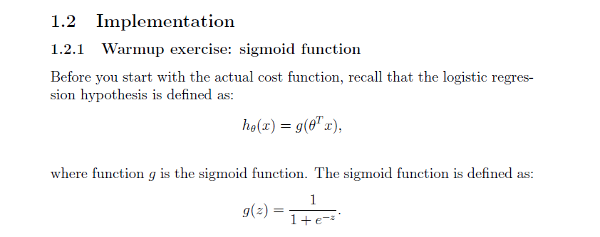

g = 1 ./ (1 + e.^-z);

1.2.2 Cost function and gradient

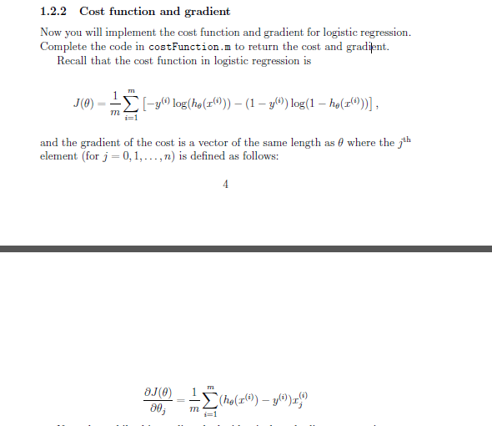

h = sigmoid(X*theta);

J = ((-y)'*log(h)-(1-y)'*log(1-h))/m;

% calculate grads

grad = (X'*(h - y))/m;

**predict**

p = sigmoid(X*theta)>=0.5;